This is a two part assignment. In the first part of the assignment you will configure a Python 2.7 environment that gets Twitter data. In the second part of the assignment you will derive “sentiments” for tweets.

# Part 1: Get Twitter Data

1. Install oauth2 library (See <https://pypi.python.org/pypi/oauth2/>.) To install the oauth2 library you will first need to install “pip”.
   1. Get the file get-pip.py from <https://bootstrap.pypa.io/get-pip.py>
   2. Execute – python get-pip.py (This will create a directory C:\Python27\Scripts\ that contains the pip executable. You may want to append this directory to your PATH environment variable.)
   3. Execute “pip install ouath2” or “\Python27\Scripts\pip install oauth2”

This is what my computer screen looked like for steps b and c.

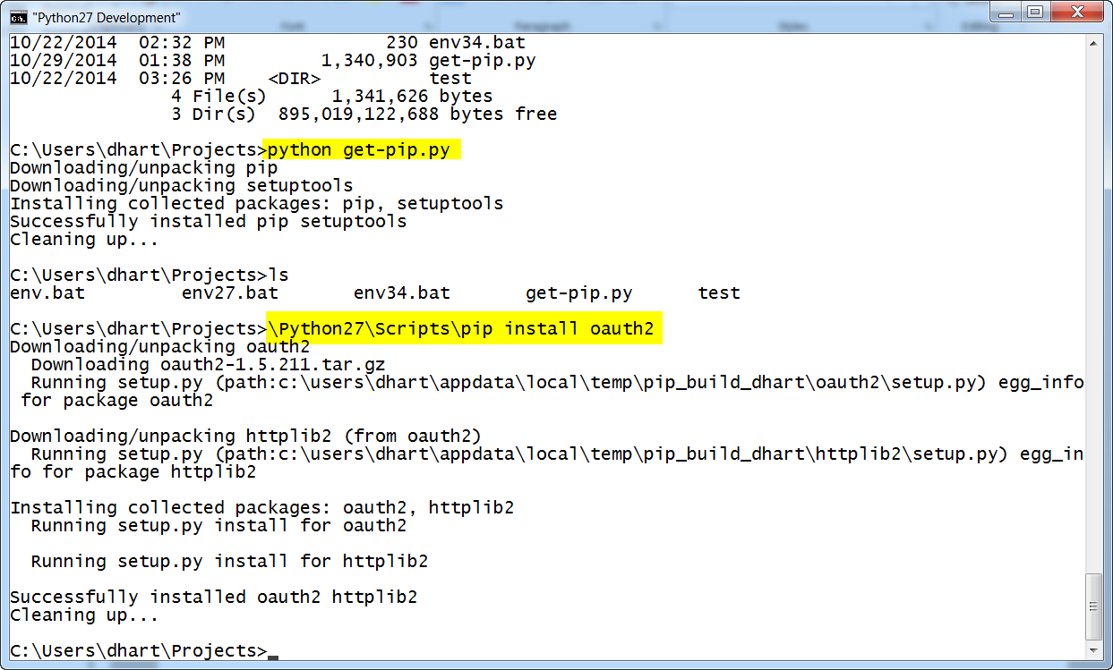

1. These steps will help you set up your twitter account to be able to access the live 1% stream
   1. Create a twitter account if you do not already have one.
   2. Go to <https://dev.twitter.com/apps> and log in with your twitter credentials
   3. Click “Create New App”
   4. Fill out the form and agree to the terms. Put in a dummy website if you don’t have one that you want to use.
   5. On the next page, click the “API Keys” tab along the top[, the scroll all the way down until you see the section “Your Access Token”
   6. Copy four values into twitterstream.py (on lines 6, 7, 8, and 9)
      1. API Key
      2. API secret
      3. Access token
      4. Access token secret

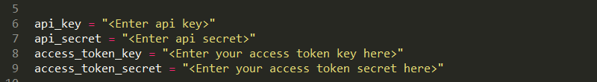

* 1. Run the following and make sure that you see data flowing and that no errors occur.

python twitterstream.py > output.txt

This commend pipes the output to a file. Stop the program with Ctrl-C, but wait for three mines for data to accumulate. Keep the file output.txt for the remaining parts of the assignment.

# Part 2: Derive the sentiment of each tweet

This will be provided later.